SOLUTION DRAIN GROUP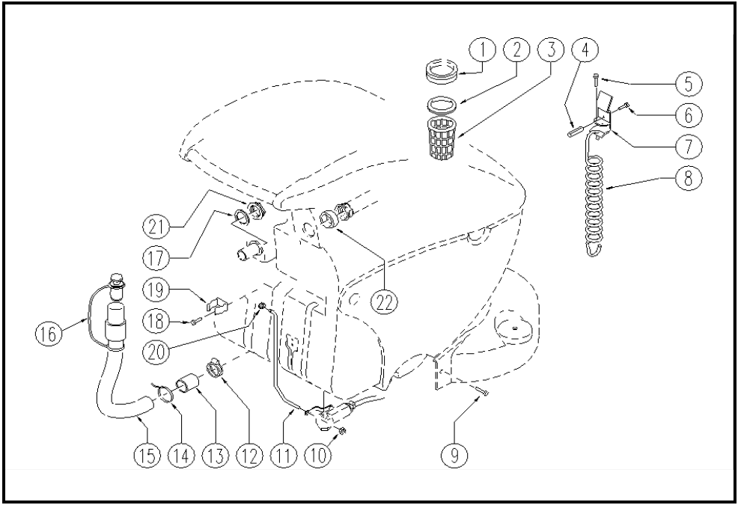

 | ITEM | SKU | DESCRIPTION | QTY | FROM
 | 1 | E87798 | Gasket WS20/24 | 1 | 10/2002
 | 2 | E87832 | O Ring for Gasket FS28 | 1 | 10/2002
 | 3 | E87799 | Filter WS20/24 | 1 | 10/2002
 | 4 | LAFN03955 | COLUMN | 1 | 10/2002
 | 5 | VTVT00751 | SCREW | 2 | 10/2002
 | 6 | VTVT00787 | SCREW M 6-16 | 1 | 10/2002
 | 7 | LAFN05121 | HOOK | 1 | 10/2002
 | 8 | MLML00205 | SPRING | 1 | 10/2002
 | 9 | E86336 | M4 - 10 Phil Pan Head Screw | 2 | 05/2004
 | 10 | E86875 | Self-Locking Nut | 1 | 10/2002
 | 11 | LAFN05759 | ROD | 1 | 02/2003
 | 12 | E86480 | Double Wire Clamp | 1 | 10/2002
 | 13 | E89506 | Drain hose protector WS20 | 1
 | 14 | E86460 | Cable tie 12" | 1 | 10/2002
 | 15 | E86523 | Hose Foreman28 | 1 | 10/2002
 | 16 | E86993 | Drain hose plug with clamp | 1
 | 17 | E89089 | Gasket | 2
 | 18 | E89473 | Screw | 2 | 10/2002
 | 19 | E86992 | Hose Clips | 1 | 10/2002
 | 20 | E89475 | Snap Ring | 1 | 10/2002
 | 21 | E89236 | Nut | 1
 | 22 | E89280 | Spacer | 1

